

Submitted to  
Sir Junaid

**BookKar Car Rental**

**Lab Mid**

**Mobile Application Development**

**Muhammad Usman Malik(FA21-BCS-072)**

**Muhammad Hozefa Rauf(FA21-BCS-057)**

**Hammad Ur Rehman(FA21-BCS-055)**

**Figma Link** : <https://www.figma.com/file/1JlpT2ZjWZozKHjYRSL7A6/Untitled?type=design&node-id=0%3A1&mode=design&t=TDYH096nXCy1tiTc-1>

Screen 1

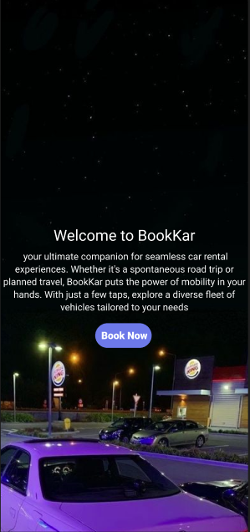

**Screen Number:** 1

**Group Member Name: (Designed & Developed by)**: Muhammad Usman Malik

**Description: 1)** Title of the company. 2) About the company. 3) Button to move from the splash screen

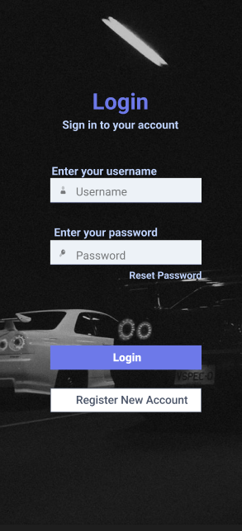

**Screen Number:** 1

**Group Member Name: (Designed & Developed by)**: Muhammad Usman Malik

**Description:** Login Screen a) Input the “Username” with the validation script b) “Password” validation with 8 digits minimum, one capital word, and a special case letter c) Disable the “Login” button if any input field is empty

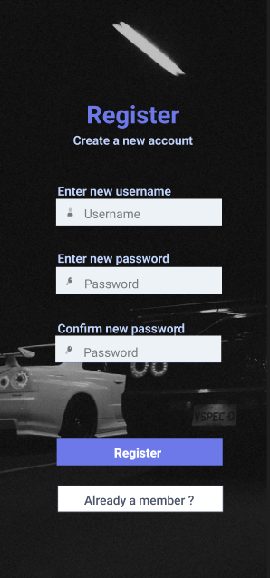

**Screen Number:** 3

**Group Member Name: (Designed & Developed by)**: Muhammad Usman Malik

**Description:** Registration Screen a) Input the username with the validation script b) “Password” validation with 8 digits minimum, one capital word, and a special case letter c) Confirm the password entered and both the passwords should match d) disable register button until all of the above checks are verified or not.

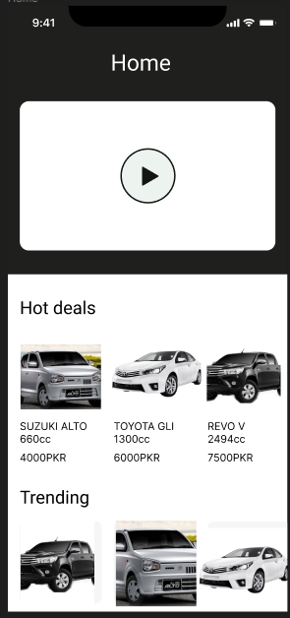

**Screen Number:** 4

**Group Member Name: (Designed & Developed by)**: Muhammad Usman Malik

**Description:** Home Screen a) Video of the company (about the company, services we offer, our offices) b) Hot Deals section with latest deals by the company displayed with their engine power and their price c) Trending section with cars that are trending displayed with their engine power and their price.

d) New section with cars that are newly entered in the company displayed with their engine power and their price.

**Screen 5:**

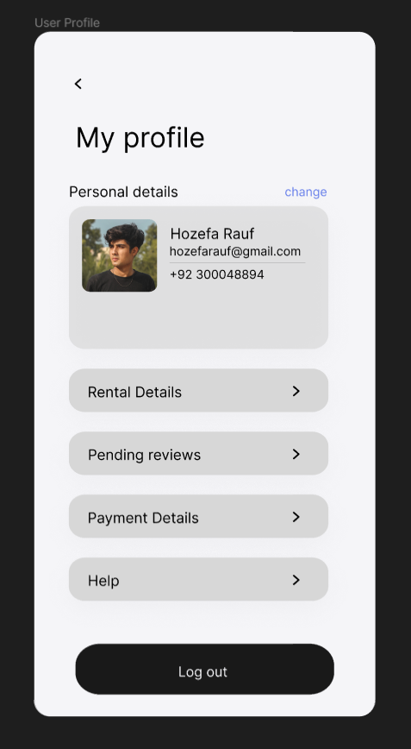

**Group Member Name: (Designed & Developed by)**: Muhammad Hozefa Rauf

**Description:** User Profile

1. Enable users to view and manage their account information.
2. rental history
3. active reservations
4. payment methods.

**Screen 6:**

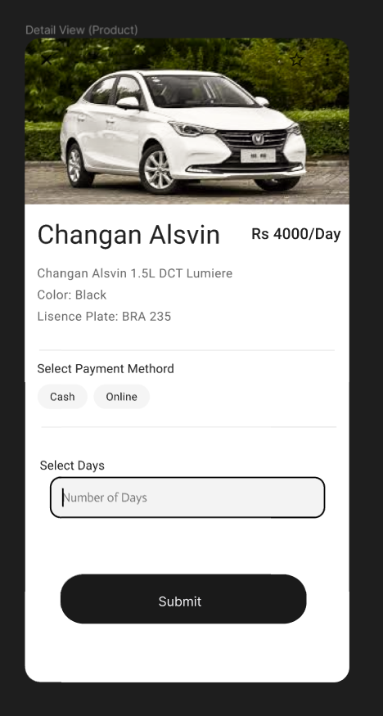

**Group Member Name: (Designed & Developed by)**: Muhammad Hozefa Rauf

**Description:** Car Detail View

1. Show detailed information about a selected car.
2. Including photos
3. Specifications (e.g., make, model, year)
4. Features
5. rental rates
6. availability calendar.

**Screen 7:**

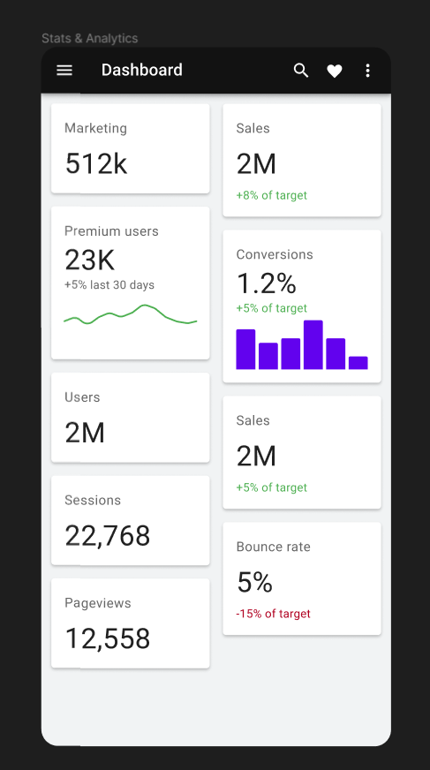

**Group Member Name: (Designed & Developed by)**: Muhammad Hozefa Rauf

**Description:** Admin Stats & Analysis

1. Administrators manage car inventory.
2. Reservations
3. user accounts
4. payments
5. analytics.

**Screen 8:**

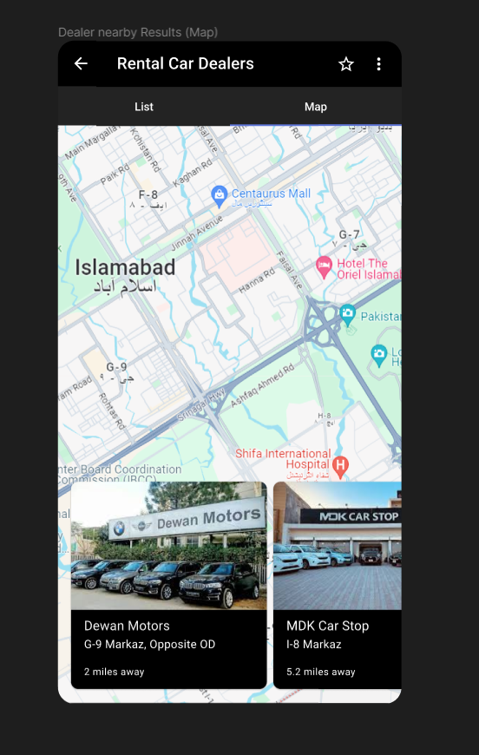

**Group Member Name: (Designed & Developed by)**: Muhammad Hozefa Rauf

**Description:** Car Dealers Nearby

1. A map view to help users locate rental car locations.
2. nearby rental agencies and points of interest.

**Screen 9:**

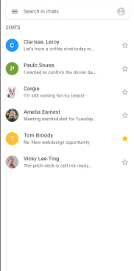

**Group Member Name: (Designed & Developed by)**: Muhammad Hammad

**Description:** Chats with dealers

1. A search bar to search chats.
2. List of all the chats.

**Screen 10:**

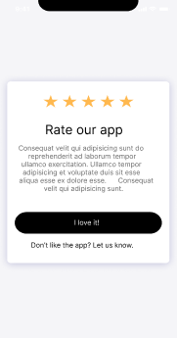

**Group Member Name: (Designed & Developed by)**: Muhammad Hammad

**Description:** App rating.

* Users can rate the app and also let us know if there is something they don’t like.

Screen 11:

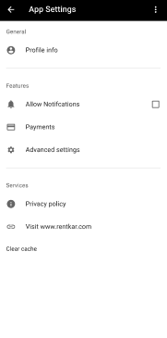

**Group Member Name: (Designed & Developed by)**: Muhammad Hammad

**Description:** App settings

1. Users can change the settings of the app as they prefer.
2. Users can control notifications settings.
3. Users can set up payment methods.
4. Users can view their profile.

Screen 12:

**Group Member Name: (Designed & Developed by)**: Muhammad Hammad

**Description:** Reporting others.

* Users can report someone if there is something wrong going on.